WVDEP sink identification project

Michael Shank
Geographic Information Officer
West Virginia Department of Environmental Protection

June 2024

The objective of this project was to create a detailed mapping of karst depressions in Monroe, Greenbrier, Pocohontas, and Pendleton Counties of West Virginia. The analysis used 1-meter elevation grids derived from lidar data made available through the USGS 3DEP program to delineate potential sink candidates. Candidates were then examined and selected by manual classification using supplemental data available for the study area.

Delineation

Feature delineation was based on a sink fill algorithm commonly used for modeling downhill flow over an elevation grid. The algorithm raises any depressions in the grid until they reach a spillover point that ensures a downhill path to the edge of the grid. By subtracting the output of the sink fill algorithm from the original elevation grid, a sink depth grid is created which can be used to identify the location, shape, and depth of depressions present in the grid.

The project used a two stage process of delineating potential karst features, both based on the sink depth grid. The initial feature set was created using a discrete features algorithm, which attempted to preserve the maximum number of depressions without combining them into composite features.

In this method, the sink depth grid is iteratively reclassified from a large value, typically representing the deepest feature in the grid, to a minimum value (in this case 10 cm) at a specified decrement. At each iteration, all values in the depth grid greater than the iterator value are assigned a value of 1 and other values are assigned null. Contiguous non-null areas are converted to a set of vector polygons, and any polygons smaller than a minimum area threshold (in this case 16 m²) are deleted. The remaining polygons then are compared with the result from the previous iteration.

If a polygon contains two or more polygons from the previous iteration it is discarded, since it has grown to the point that it has merged multiple sink features. If a polygon contains one polygon from the previous result, it replaces the previous result, because it represents the same feature and has not yet merged with an adjacent feature. If a polygon contains zero polygons from the previous result, it also is retained, because it represents a new local feature that occurs at a higher elevation and has grown large enough to exceed the minimum area threshold.

The result maintains the maximum number of sink features larger than the minimum area without encompassing any two of them. Their boundaries represent the largest delineation that does not incorporate another feature, limited by the resolution of the decrement size.

It should be noted that this algorithm also was implemented using contour polygons in place of reclassified grids. This alternative had two advantages– it was faster, and it produced visually appealing polygon boundaries, because the contour algorithm employed a good feature simplification algorithm. This alternative ultimately was not selected for two reasons. First, it appeared to miss some smaller features, though the cause was not pursued. Second, the unsimplified boundaries created by the original process were considered to be more precise for calculating depth statistics from the source grids.

This algorithm is effective at dealing with larger structural depressions in a karst region that may contain dozens or even hundreds of individual sinkholes. However it occasionally will preserve adjacent features separated by inconsequential barriers or noise artifacts that do not effectively represent a larger feature. For example, figure 1a shows 2 initial polygons split by random variation on the floor of a larger sink, and figure 1b shows an impoundment constructed within a much larger sink feature. To handle these cases, the algorithm was modified to validate whether a particular feature was part of an ‘ignore list’, in which case the feature would not be carried over to the next iteration and the sink growth would be allowed to continue. Therefore the analysis involved running the algorithm twice– once to create an initial candidate set, and a second time after creating the ignore list.

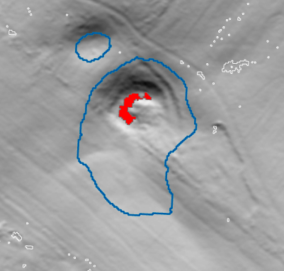  a | 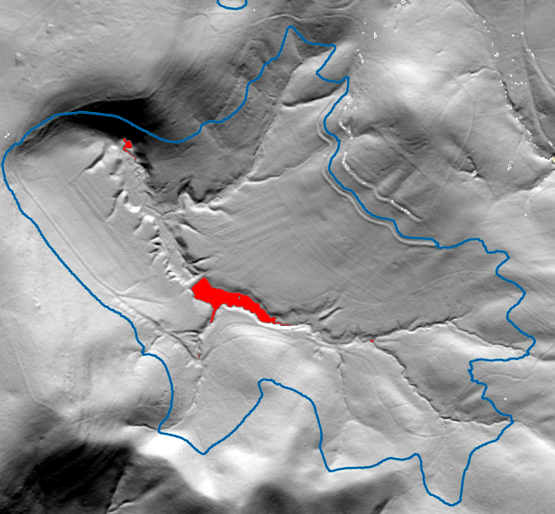  b
figure 1. examples of failures in the discrete features delineation algorithm that were handled by creating an ‘ignore list’ when running the algorithm.

Classification

Automated approaches to classification were considered, but it ultimately was decided to adopt a manual classification process using primarily hillshade, aerial photography and flow accumulation grids to discriminate karst features from noise artifacts or other features like impoundments. While one of the ancillary goals of the project was to create training and validation datasets for use in investigating deep learning algorithms with elevation derivatives and multi source inputs, we didn’t want to significantly expand the scope of the study at the risk of delaying an initial product.

Threshold depth delineation

After an initial classification of the discrete features candidate set, the identified karst features were used to modify the elevation grid by replacing elevations within the feature boundaries with a null value. The sink fill algorithm then was run again,, which effectively prevented the creation of large composite depressions in the fill depth grid. The modified fill grid values were reclassified to identify areas with a fill depth greater than 1 cm and these areas were converted to vector polygons, creating a second candidate set consisting of smaller and shallower features than originally detected using the discrete feature algorithm. Again, individual candidates were selected using several supporting layers including hillshade images and aerial photography. These features then were combined with the initial feature set to create the final combined sink feature dataset.

Depth estimation

Sink depth was calculated as the range of elevations occurring within the polygon boundary. Maximum fill depth within the polygon also was calculated. The latter measure probably is a more reliable estimate of feature depth for small features, but it is not universally applicable because thousands of sinks occur within larger composite depressions. For these features the fill depth value represents the depth relative to the larger depression and not the feature itself. Maximum fill depth was useful for evaluating the reliability of the elevation range calculations for a sample set of 8,474 sinks that did not occur within a composite depression. The average difference between the two depth calculations was inversely proportional to the size of the feature: 0.8% for features that were 64 m² area, rising to 2.4% at 32 m², 4.2% at 16 m², 9.6% at 8 m², and 38.7% at 4 m². It also should be noted that many small features are very shallow, and differences of a few centimeters can account for a large percentage difference between the two methods.

Composite feature delineation

A supplemental feature class was added to the result data that delineated all depressions in the study area greater than 10 cm depth that also contained four or more discrete sink features. This layer was used to visualize the grouping of sinks within larger composite features (e.g., figure 2) , which may contain dozens or hundreds of individual sinks within the boundary of a single depression.

Point feature class

Another supplemental feature class was created by identifying the deepest point, or lowest point of drainage, within each sink feature. Combined with a set of depth contours, this feature class assisted in visualizing the structure of larger sinks and surface drainage within their boundaries.

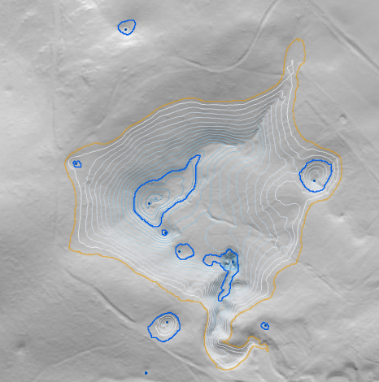
Figure 2. typical composite feature (orange) delineating a depression containing multiple discrete sinks.

Feature Classes:

sinks_poly | polygon features identified as sinks, including candidates from both the discrete features algorithm and the threshold depth delineation. Boundaries were not simplified when converting from the original raster and exhibit an angular step effect when viewed at a large scale.  Attributes:  method– method used for delineating the polygon. Includes discrete features – derived by the discrete features algorithm, threshold depth 1cm – created from the modified grid using a 1 cm fill depth, threshold depth 10cm – created using a threshold fill depth of 10cm. This was used for a section of the study area in Northwest Pocahontas County. It produces results identical to the discrete features algorithm for areas that do not contain compound depressions containing multiple individual features.  elevation_range– the range of elevations from the elevation grid found within the boundary of the polygon. Provides a good indication of fill depth when the feature is of sufficient size.
sinks_composite | compound depressions, delineated at the 10cm fill depth level, containing four or more discrete sink features. Useful for delineating larger areas that may contain dozens, or even hundreds, of individual sink features.
sinks_pnt_max_depth | point within a sink polygon that corresponds to the maximum depth, or the lowest point of surface drainage. Note that there is at least one point for each sink, but a sink can have more than one associated point of maximum depth within the boundary of the feature.

